 | BJMHR  British Journal of Medical and Health Research  Journal home page: www.bjmhr.com
Opinion: The Double Cause Hypothesis may explain Environmental factors' effects associating with type 1 Diabetes

Ran Arieli PhD^{1,2}
1.Eliachar Research Laboratory, Western Galilee Medical Center, Nahariya,
2.The Israel Naval Medical Institute (INMI), Haifa, Israel

ABSTRACT
We have shown the existence of permanent bubbles on Active hydrophobic Spot (AHS) at the luminal aspect of blood vessels. This led us to suggest the Double Cause Hypothesis (DCH) for autoimmune diseases when an autoantigen precursor spill into the blood and being deformed at gas/liquid interface to become autoantigen. Increased spillage of autoantigen precursor from β-cells due to enterovirus infection and elevated AHS due to lipids in the blood are suggested as environmental factors which increase the risk in acquiring T1DM. Further research lines are suggested.
Keywords: Lung surfactant, nanobubbles, Active Hydrophobic Spot, Autoimmunity, β-cells

*Corresponding Author Email: arieli1940@gmail.com
Received 02 April 2026, Accepted 13 April 2026

INTRODUCTION
Persistence gas phase at the luminal aspect of blood vessels
Active Hydrophobic Spot – (AHS)
The main risk in diving while surfacing from the dive is decompression illness when bubbles are produced from dissolved nitrogen. While studying decompression bubbles after diving, we found that lung surfactant dipalmitoylphosphatidylcholine (DPPC) leaks into the plasma and settles on the luminal aspect of blood vessels to create an hydrophobic spots (AHS). Nanobubbles of ~ 100 nm are formed at the AHS.¹ These nanobubbles are the "seeds" from which bubbles expand during decompression from diving. Thus, regardless of diving, the consequence is prevalence of constant gas phase of nanobubbles in anyone who have high levels of AHS.
Blood lipids and AHS expansion
In a study of the effect of a fatty diet on decompression bubbles, following hyperbaric exposure, divers were divided into two groups: bubblers, for which many venous bubbles were detected using ultrasound and non-bubblers.² Bubblers had higher fat consumption than non-bubblers as a function of their expected value (146 % versus 92%). Cholesterol and triglycerides in serum were high in the bubblers compared with the non-bubblers. The main surfactant in the lung is DPPC (40%), with the presence of additional components including other phospholipids, glycerides, and cholesterol. We suggested that, as with the different lipids which compose the layers of surfactant in the lung, some of the additional lipids carried by the blood will attach themselves to the AHS, thus contributing further to their enlargement.³ Divers who consume food that is high in fat, and as a result have more lipids in their blood, will therefore develop more and larger AHS, and subsequently becoming bubblers with a higher risk of decompression illness. The implication, again regardless of diving, is that high lipids in the blood should increase the amount of nanobubbles at the luminal aspect of blood vessels.
Double Cause Hypothesis – (DCH) for the origin of autoimmune diseases
A permanent gas phase at blood vessels led us to propose Double Cause Hypothesis – (DCH) for the origin of autoimmune diseases.⁴ The DCH suggest two independent processes: 1. The existence of many and large AHS, and 2. The leakage of autoantigen precursors (a protein which can be transformed to autoantigen- specific for each disease) into the blood. Profuse production of autoantigen precursors was recently defined as a cause of autoimmune diseases.⁵ Hydrophobic part of the protein bulge into the gas apace while hydrogen bonds are broken. As consequence, neu-epitopes are exposed. The autoantigen precursor is suggested to transforme into an autoantigen. There are ample documentations on coagulation of proteins at the gas/liquid interface when oxygen bubbling was used to oxygenate the blood.⁴ The scheme of DCH is presented in Figure 1.
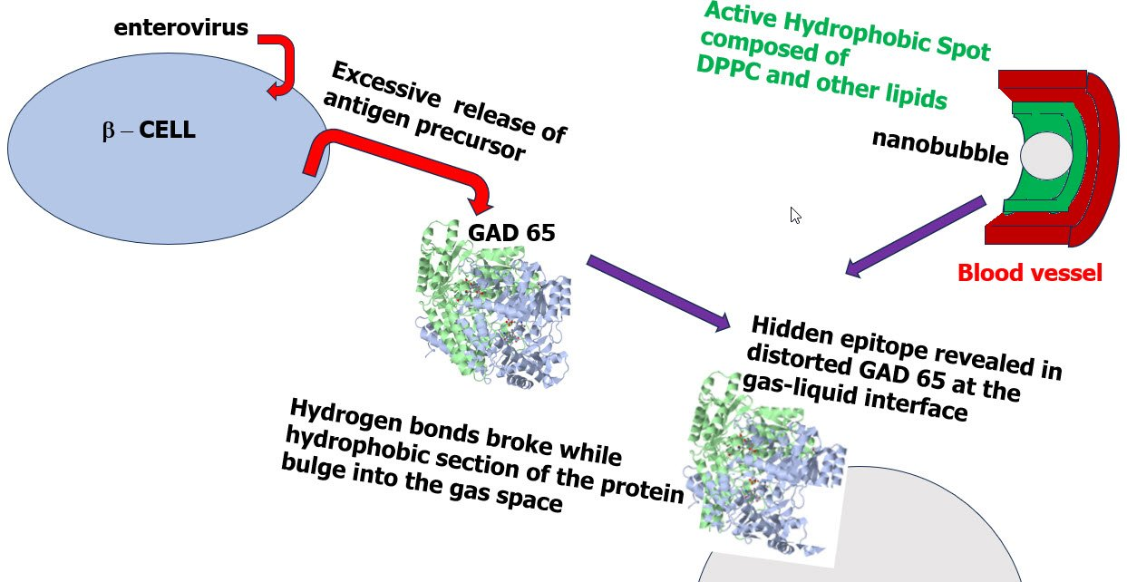
Figure 1: Schematic presentation of the Double Cause Hypothesis for the origin of autoimmune disease (T1DB as an example).
Experimental support of the DCH in diabetic mice (NOD)
For the production of the AHS, DPPC typically leaks from the lung to the blood and then settles at the luminal aspect of blood vessels. We wonder if patients afflicted with T1DM have increased spillage of DPPC. However, the plasma content of DPPC in diabetic patients was not above that of the controls.^{6, 7} We therefore assumed that the risk in T1DM could be related to the amount of DPPC settled upon the blood vessels. Some of the non-obese diabetic (NOD) mice are affected by T1DM while other remained healthy. DPPC content was determined in the heart of diabetic and healthy NOD mice and two control mice strains (C57/BL6 and Swiss-webster). There was no difference in DPPC level between the two NOD groups.⁵ The hearts from NOD mice contained more DPPC (47.6 mg/g) than the control mice (36.9 mg/g) (P < 0.018). Thus, the first requirement of the DCH was supported: An increased level of DPPC and AHS. We think that leakage of an autoantigen precursor from β-cells (the second cause) is the difference between affected and non-affected NOD mice. Thus, the DCH is partly supported. We suggested further research on the spillage of autoantigen precursors from β-cells to the blood to explore the second requirement of the DCH.
Environmental effects on type 1 diabetes - T1DM
There are two main environmental effects which are linked to the risk in acquiring T1DM: 1. Early infection of enterovirus that can harm β-cells.⁸⁻¹⁰ 2. Increased incidence with calendar years, higher income, unhealthy diet and a relation to geographical locations (different countries) and education¹¹⁻¹⁴ No accepted common explanation was suggested for these environmental factors.
- Recent Meta Analyses found a significant link between blood and tissue evidence for enterovirus infection and T1DM in European, African, Asian, Australian and Latin American populations. Enterovirus infection can destroy β-cells, decrease in insulin mRNA expression and insulin secretion and the disruption of the Golgi Apparatus. Autoimmunity appears several months or more after the enterovirus infection. It is still not clear which of the enterovirus strains contribute to the occurrence of T1DM. However, the CVB1 is one of the most cytosolic enteroviruses, known to attack β-cells. Balance is suggested between destruction of β-cells infected with the enterovirus and their preservation in order to preserve viable β-cells. It is suggested that β cells are infected by enterovirus with slow nonlytic replication and the enterovirus can spread slowly between islet β-cells. There are indications that pre-existing inflammation of the islets may be needed for the contribution of virus infections.
- Incidence of T1DM increased between 1995 and 2025. Countries such as the United Arab Emirates, Oman and Saudi Arabia have reported an immense increase in T1DM, while Tanzania, Yemen and Indonesia saw a small increase. The incidence of T1DM correlates to the level of income and is 8 times higher in high-income than in in low-income populations. The incidence in Western Europe decreases as education level is increased. The prevalence of T1DM is lower in high altitude compared to low altitude. Finally, it is suggested that obesity contributes to T1DM.
T1DM, DCH and environmental factors
Environmental effects of enterovirus
Inflammation and lysis of β-cells by enteroviruses could cause excessive spillage to the blood of autoantigen precursors like insulin, Glutamic acid decarboxylase (GAD65), insulinoma-associated antigen 2 (IA2) and zinc transporter 8 (ZnT8). Increased autoantigen precursors in the blood would increase the chances of such molecule adhering to the gas-liquid interface of the nanobubble and activating autoimmunity.
Environmental effects of time, income, location, and education
Blood lipids and T1DM
It is well known that patients with T1DM have an elevated combined level of triglyceride, low-density lipoprotein (LDL) and cholesterol in the blood.^{15, 16} No one measured if prior to the acquisition of autoimmunity, these patients had pre-existing high levels of blood lipids. High cholesterol has shifted from high income countries in northwestern Europe, north America and Australasia to middle income countries in east and southeast Asia from 1980 to 2018,¹⁷ similar to the time and income relations in T1DM. Ogrotis et al.¹² claim that obesity and un-healthy eating patterns play a role in the genesis of autoimmune diabetes. Less educated women had worse lipid profiles than women with high education.¹⁸ This may correlate with evidence from western Europe where as education levels are higher, the incidence of T1DM is lower. It is possible that high blood lipids are expected in those who got low education and do not control fat consumption, and in people who consume unhealthy food and in obese ones.
Suggested environmental factors which enhance T1DM.
We wonder whether all the environmental factors: calendar years; income; education and geographical locations share a common cause of elevated amounts of lipids in the plasma. We stress plasma, because some water insoluble lipids are carried by proteins. High levels of lipids in the blood should increase the level of AHS and bubbles and may also increase the risk in the development of T1DM. This assumption should be studied further and if it will be confirmed, appropriate actions should be recommended.
CONCLUSION
The DCH suggests that T1DM is enhanced by two environmental factors: An enterovirus attack which causes the release of autoantigen precursors from β-cells into the blood, and high amounts of lipids in the blood which produce extensive sites of nanobubbles at the hydrophobic spots on the luminal aspect of blood vessels. Verification of this theory could lead to new standards of prophylactic measures for reducing the incidence of T1DM. Therefore, I suggest:
- Longitudinal survey of blood lipids in youngster populations, as related to the appearance of TIDM.
- Radiolabel marking of the amount of DPPC at the AHS for assessment of the risk in acquiring T1DM by comparison of T1DM patients with control.
- If DCH is proved, blood lipids should be controlled.
- Consider vaccination against enteroviruses.
- And perhaps in the future Removal of the DPPC from the AHS and thus eliminating the nanobubbles.
ACKNOWLEDGMENTS.
The authors thank Mrs. P. Braiman for skillful editing of the manuscript. Only one author have contributed significantly and in keeping with the latest guidelines of the International Committee of Medical Journal Editors, each author’s contribution to the paper is to be describe that role each author participated in.
AUTHORS CONTRIBUTION
RA is the only author who raise the concept, wrote and reviewed the manuscript.
FUNDING INFOTMATION
None.
DISCLOSURE No potential conflict of interest relevant to this article was reported.
ORCID
Ran Arieli https://orcid.org/0000-0001-8925-0396
REFERENCES
- Arieli R. Nanobubbles form at active hydrophobic spots on the luminal aspect of blood vessels: consequences for decompression illness in diving and possible implications for autoimmune disease-an overview. Front Physiol 2017; 8:591.
- Kaczerska D, Siermontowski P, Olszański R, Krefft K, Małgorzewicz S, Van Damme-Ostapowicz K. The influence of high-fat diets on the occurrence of decompression stress after air dives. Undersea Hyperb Med 2013; 40:487‒97.
- Arieli R. Fatty diet, active hydrophobic spots, and decompression sickness. Letter to the Editor. Diving Hyperb Med 2018;48:197
- Arieli R. Was the appearance of surfactants in air breathing vertebrates ultimately the cause of decompression sickness and autoimmune disease? Respir Physiol Neurobiol 2015;206:15-18.
- Aburomi N, Khatib S, Piran R, Arieli R. The double cause hypothesis for autoimmune diseases is Supported in Diabetic Mice (NOD). Medical Res Arch 2023;11:12
- Arieli R., Khatib S., Khatib A., Bukovetzky E., Gottfried O.D. Is the probable spillage of the lung surfactant dipalmitoylphosphatidylcholine the ultimate source of diabetes type1? Respir Physiol Neurobiol 2020;286:103615.
- Arieli R, Khatib S, Tarabeh A, Bakry D, Bukovetzky E, Gottfried OD Testing the Double Cause Hypothesis for autoimmune diseases, dipalmitoylphosphatidylcholine should be measured in plasma or blood vessels of diabetes Type 1? Medical Res Arch 2023;11:4.
- Isaacs SR, Roy A, Dance B, Ward EJ, Foskett DB, Maxwell AJ, Rawlinson WD, Kim KW, Craig ME. Enteroviruses and risk of islet autoimmunity or type 1 diabetes: systematic review and meta-analysis of controlled observational studies detecting viral nucleic acids and proteins. Lancet Diabetes Endocrinol 2023;8:578-592.
- Lloyd RE, Tamhankar M, Lernmark A Enteroviruses and type 1 diabetes: multiple mechanisms and factors? Annu Rev Med 2022;73: 483–499.
- Wang K, Ye F, Chen Y, Xu J, Zhao Y, Wang Y, Lan T. Association between enterovirus infection and type 1 diabetes risk: a meta-analysis of 38 case-control studies. Front Endocrinol 2021; 12:706964.
- Borchers AT, Uibo R, Gershwin ME . The geoepidemiology of type 1 diabetes. Autoimmun Rev 2010;5:A355-365.
- Ogrotis I, Koufakis T, Kotsa K. Changes in the global epidemiology of type 1 diabetes in an evolving landscape of environmental factors: causes, challenges, and opportunities. Medicina 2023;59:668.
- Qick M, Christtiansen J, Bryner J. The growing global burden. Sci Am 2025;333(4): s10-s11.
- Sidahmed S, Geyer S, Beller J. Socioeconomic inequalities in diabetes prevalence in Europe. SAGE Open 2025;15: 1–14.
- Vergès B. Lipid disorders in type 1 diabetes. Diabetes Metab 2009 ;35(5):353-60.
- Oki JC. Dyslipidemias in patients with diabetes mellitus: classification and risks and benefits of therapy. Pharmacotherapy1995;15(3):317-337.
- Taddei C, Zhou B, Bixby H, Carrillo-Larco RM, et al. NCD risk factor collaboration (NCD-RisC). Repositioning of the global epicentre of non-optimal cholesterol. Nature 2020; 582:73–77.
- Lara M, Amigo H. Association between education and blood lipid levels as income increases over a decade: a cohort study. BMC Public Health 2018; 18:286.


BJMHR is
- Peer reviewed
- Monthly
- Rapid publication
- Submit your next manuscript at
editor@bjmhr.com

